Medical Supply Inventory Management Project

Name: Arrabiona Nagamani

Batch number: BN003

Project Title: Medical Supply Inventory Management

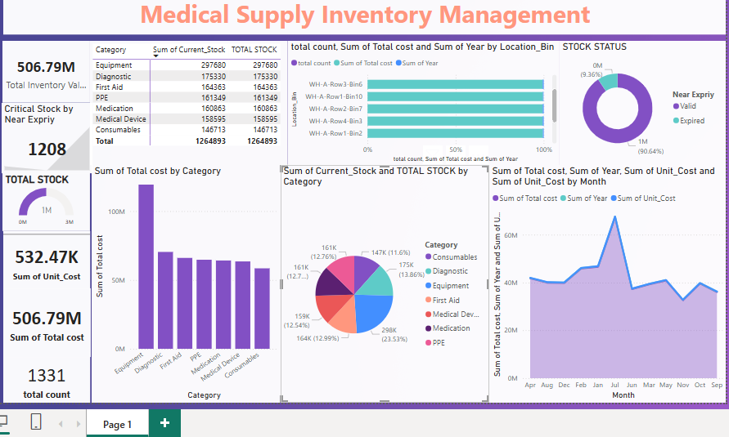

1.which item has the highest/lowest stock?

2.what is the total quantity each item?

3.which department consumes the most supplies?

4.how to visualize this data in powerbi

5.how to improve inventory turnover ratio?

6.How much total cost?/total unit cost?

7.how much average each Item value?

8.what is total count?how many category are there?

Step 1: Project Objective

Manage and monitor stock of medical supplies.

Track expiry, stock level, and total value.

Help avoid wastage and improve purchase decisions.

Step 2: Load Your Dataset

Open Excel.

Click on File → Open → Select your file (CSV or Excel).

Your dataset includes columns like:

Item Name

Category

Unit Cost

Current Stock

Total Cost &,Expiry Date

Step 3: Clean the Data
Go to Home → Find & Select → Go To Special → Blanks → Fill in missing values

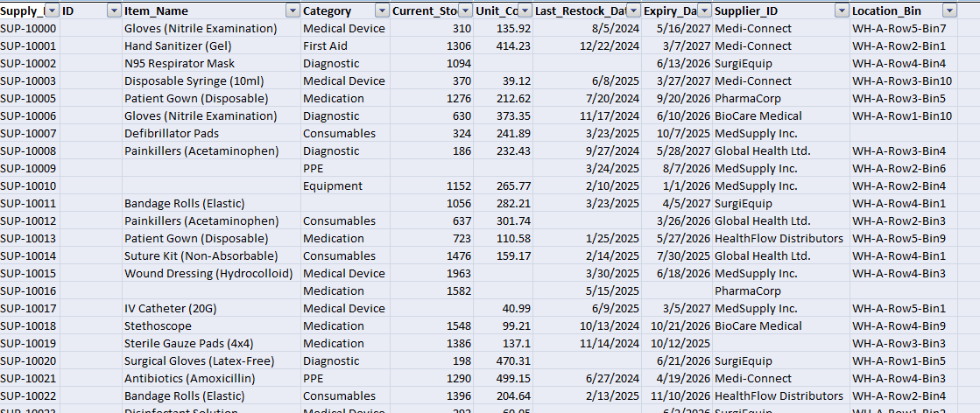SuppluId used for Right function:

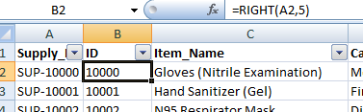

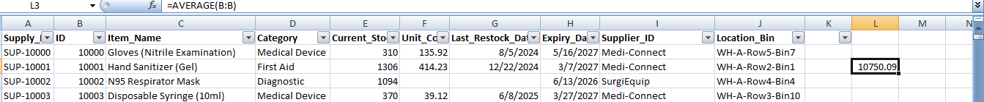

Average function used above sheet

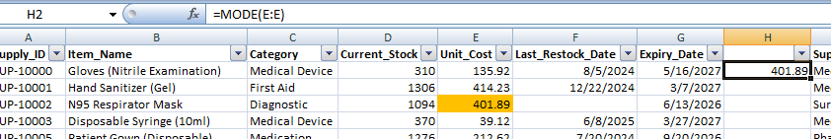

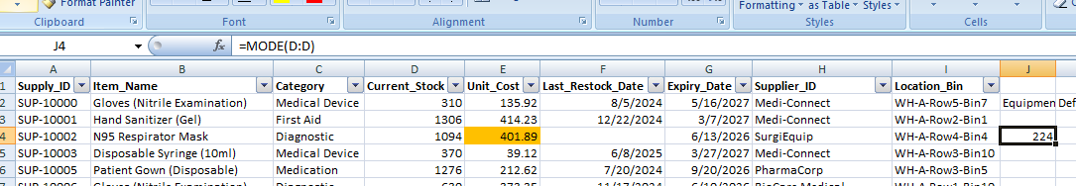

Fill missing Category using formula =INDEX(H2:H1332,MODE(MATCH(H2:H1332,H2:H1332,0)))

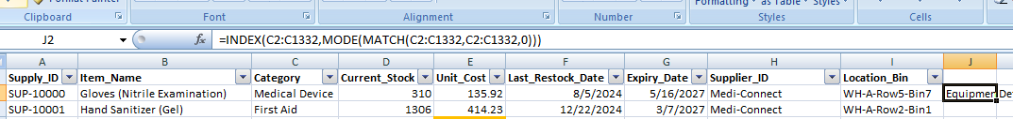

Create “Total Cost” column:
= Unit Cost × Current Stock
Example: =D2 × E2

=Table3[[#This Row],[Total Cost]]

Create a “Status” column:
=IF(AND(G2>=TODAY(),G2<=TODAY()+90),"Expired","Valid")

Step 4: Create Pivot Tables
Pivot Table 1:

Rows: Category

Values: SUM of Total Cost, SUM of Current Stock

Pivot Table 2:

Rows: Expiry Status

Values: COUNT of Item Name

Pivot Table 3:

Rows: Month (from Purchase/Expiry Date)

Values: SUM of Total Cost

Step5: Insights

Which category has the most cost?

How many items are near expiry?

Which months had higher costs?

Which location stocks the most?

Step 1: Project Objective

This project is to manage medical supplies inventory effectively.

Goals:

Track stock levels.

Monitor expiry dates.

Analyze costs by category and month.

Improve decision-making for purchases and inventory turnover.

Step 2: Import Data

Imported medical supply inventory data (Excel/CSV file).

Key columns:

Item Name

Category (Equipment, Consumables, Medication, etc.)

Current_Stock

Unit_Cost

Total_Cost (calculated as Current_Stock × Unit_Cost)

Expiry Date

Location

Step 3: Data Cleaning and Transformation

Used Power Query Editor:
Removed duplicates and null values

Step 4: Build the Dashboard

Designed a Power BI dashboard with the following visuals:

KPI Cards

Total Stock

Total Cost

Near Expiry Count

Bar Chart

Total Cost by Category

Pie Chart

Current Stock Percentage by Category

Line Chart

Monthly Total Cost Trend

Donut Chart

Stock Status (Expired, Near Expiry, ValTable)

Detailed view of Item Name, Category, Stock, Unit Cost, Expired

Step 6: Insights

Found which category is highest in cost.

Identified stock near expiry to prevent wastage.

Tracked monthly purchase trends to avoid overstocking.

Helped in improving inventory turnover ratio.

